**SRS**

**for Vinaswap project**



**Author: Imagineers Team**

**Date: Jan 25, 2016**

**Revision history**

|  |  |  |  |
| --- | --- | --- | --- |
| **Version** | **Date** | **Author** | **Notes** |
| **1.0** | 25/01/2016 | Phuong Nguyen | Created |
|  |  |  |  |
|  |  |  |  |

**TABLE OF CONTENT**

I. Introduction 4

II. Overall Description 6

III. Other Nonfunctional Requirements 7

**List Of Figures**

Fig 1. System Context 6

# Introduction

## Purpose

This SRS document describes the website functional and nonfunctional requirements for release of the Vinaswap Project. This document is intended to be used by the members of the project team that will implement and verify the correct functioning of the system.

## Intended Audience and Reading Suggestions

## Product Scope

The Swappal website will permit the Internet users to create profile and and swap skills with other people on website. A detailed project function is available in the Imagineers’s Product backlog : Imagineers-Productbacklog.xlsx

Functional requirements:

* Internet user:
  + - View the website information
      * Main page
      * FAQs page
      * News page
      * About us page
      * Contact page
      * Member’s page
    - Search Skills
    - Sign up
      * Via Facebook
      * Via Email
    - Sign in
      * Via Facebook
      * Via Email
  + Member:
    - Log out
    - Reset Account password
    - Manage Account
    - Create member’s own page
    - Manage Profile
      * View “review” page
      * Edit "About Me" page
      * Edit "my page"
      * View "about me"
      * View "my page"
      * View the request page
    - Swapping
      * Request swap
      * Exchange swap detail
      * Auto match
    - Feedback
      * Post feedback to member’s page
      * Submit feedback to site
* Staff:
  + - Manage user account
      * Ban user account
    - Manage site activities
      * View report of the site
      * Post news on the site
      * Delete the news
    - Manage User feedback
      * Review all the member's feedbacks

## References

* Imagineers-Productbacklog.xlsx

# Overall Description

## Product Perspective

The customer wants to have a website to swap skills among all the users. It’s a non-fee service, people can swap to learn new skills without costing much money.

For our customer, the Swappal is a website to help people learn new skills and make friends. Unlike other similar website in the market, our site is currently non-fee and easier for user to interact with the system. We are provided not only the site for swapping, we also will create a big and strong community for people to share and understand each other, help building trust with a safe environment

## User Classes and Characteristics

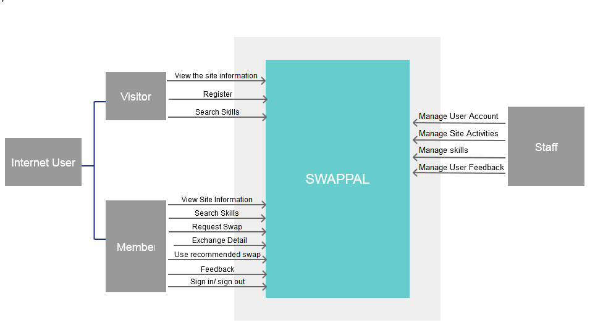

Fig 1. System Context

* Internet user : is anyone with the access to internet who want to visit and interact with the site and who wishes to exchange skills
* Visitor : A non-registered User
* Member: A user who has an account and can conduct swapping.
* Staff: Swappal staff who manage the site information and users

## Operating Environment

OE-1: The system works in the window phone and it is an smartphone application.

OE-2: The system uses database to control all the data.

OE-3: The system has the server to hold all the data.

## Design and Implementation Constraints

CO-1: The system shall use MongoDB database engine.

CO-2: All Backend code shall conform to the Visual Code and Nodejs tool.

CO-3: All layout shall conform to the Atom

CO-4: All layout shall be written in HTML language.

CO-5: All backend shall be written in Javascript and Typescript language.

CO-6: Data holds in server in Digital Ocean.

## User Documentation

No user documentation have been identified.

# Other Nonfunctional Requirements

## Software Quality Attributes

* Usability: Friendly-Using website so that all user know how to interact with website after one visit.
* Availability: The system must be able to work 24/7
* Portability: User can use website browsers on computer or website browsers on smartphone